Interview | Date | Time | No
First
Second
Skype Id
Deviation Letter (If Any)
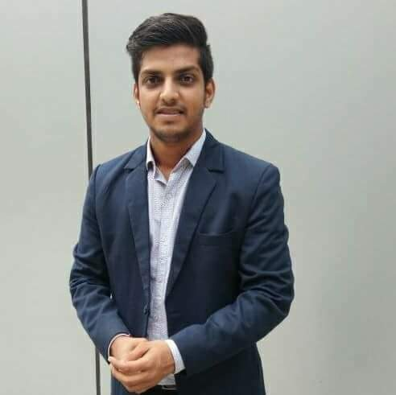

APPLICATION FORM
(Fill with neat handwriting/Typing) DATE: 7-Nov-26

POST APPLIED FOR: | Sales and marketing promotion
FULL NAME:  (In block letters) | PIYUSH HIRALAL LOHAR
APPLIED WITH REFERENCE:  (Recruiter’s Name) | Mitali barot

Mobile No. | 8855099614
Email ID | Piyushlohar400@gmail.com
Date of Birth | 26 sept 1993
Marital Status | Single
Gender | Male
Aadhar Card | Yes
Passport | Yes
Category: General/SC/OBC/ST/If Others (Specify) | General
Have you been interviewed by us?  If yes, please specify date of interview | No
Do you know any of our employees?  If yes, please specify name & relationship: | No
Are you pursuing/ planning any further  educational course? If yes, please specify | Yes ( PDGM in marketing ) part time

QUALIFICATION DETAILS: (Start With Latest Qualification)
Qualification | Specialization | School / College / University | Year of  Passing | % / Grade | Medium of  Education | Full /Part  Time / Distance
BBA | Marketing | Sathyabama | 2014 | 74 | English | Full time
Hsc | Science | Mumbai university | 2011 | 61 | English | Full time
Ssc | - | Mumbai university | 2009 | 60 | English | Full time

MENTION THE APPROPRIATE OPTION |  |  |  |  | YES / NO
Open to Field work |  |  |  |  | Yes
Open for travelling for Exhibitions / Seminars in |  |  |  | INDIA | Yes
 |  |  |  | ABROAD | Yes
Addictions | Tobacco |  |  |  | No
Addictions | Smoke |  |  |  | Occasionally
Addictions | Alcohol |  |  |  | Occasionally
PHYSIOLOGICAL INFORMATION:
Blood Group |  | Height | Weight
AB+ |  | 159cm | 65kg
Health Hazards / Physical disabilities (If Yes, Please specify below) |  |  | Yes / No
No

ADDRESS DETAILS:

CURRENT ADDRESS |  | NATIVE ADDRESS
Communication Residence Address: | G-201, Neminath nagar Achole road  Nalasopara East Mumbai | Native Place: | Same as above
City/ District/ Village: | Mumbai
Pin Code: | 401209
State: | Maharashtra
Landmark: | Jaya palace hotel

FAMILY DETAILS:

First Name | Middle Name | Last Name | Date of Birth | Relationship | Occupation
Hiralal | Chogalal | Lohar | 2nd june 1963 | Father | Retired
Savita | Hiralal | Lohar | 12th may 1972 | Mother | House wife
Manish | Hiralal | Lohar | 31st july 1992 | Brother | Accountant

COMPUTER/ SOFTWARE PROFICIENCY:

* TICK “√ ” IF YOU KNOW & “X“IF YOU DO NOT KNOW IN SKILL CHECK BOX

* IF YOU KNOW THEN MENTION THE DETAILS IN GIVEN RESPECTIVE COLUMNS.

SOFTWARE | SKILL * | VERSION/ TYPE | BASIC | ADVANCE
MS WORD |  | MS office 2016 |  | Advance
MS EXCEL |  | MS office 2016 |  | Advance
MS OUTLOOK |  | MS office 2016 |  | Advance
MS POWERPOINT |  | MS office 2016 |  | Advance
INTERNET |  | CHROME |  | Advance
TALLY | €
PHOTOSHOP | €
COREL DRAW | €
AUTO CAD | €
ANSYS | €
CREO PARAMATRIC/ PRO ENGINEER | €
CATIA | €
DRAFT SIGHT | €
SOLID WORKS | €
SOLID EDGE | €
TURBO CAD | €
OTHER (PLEASE SPECIFY)

LANGUAGES KNOWN:

Languages | Speak | Read | Write
English | Yes | yes | Yes
Hindi | Yes | Yes | Yes
Marathi | Yes | Yes | Yes
Gujarati | Yes | No | No
Mother Tongue:- | Marwadi

I hereby declare that all the information given by me is true. In case, any of the information is found to be incorrect then company can take action against me including termination

DATE: 7-Nov-26 SIGNATURE: piyush lohar
DETAILS OF PRESENT & PREVIOUS ORGANIZATIONS
(Start With Current Employer)

Company Name | Designation | Location | Employment Period |  | Salary  Drawn  (CTC Per  Annum) | Reason for  Leaving
Company Name | Designation | Location | From  (MM/YY) | To  (MM/YY) | Salary  Drawn  (CTC Per  Annum) | Reason for  Leaving
Adwallz outdoor advertising pvt ltd | Sr. Manager | Goregaon | Feb 2018 | Aug 2018 | 6lac | Better future
Vritti solution limited | Assistant manager | Malad | Nov 2016 | Oct 2017 | 4.84 lac | Personal issues
Triforce (Appco group ) | Team leader | Baroda | Jul 2014 | Oct 2016 | 3.5lac | Growth

CURRENT JOB DESCRIPTION:

- Making presentation for different category client
- Event calendar, catalogue, broachers, templates content writing or eye Catchy tag line
- Creative idea as per product and along with advertisement medium such as ATL , BTL, TTL, digital marketing
- Brand awareness, product launch residential campaign, customized campaign, concept creativity etc...
- Stall design, innovative stall ideas and execute the events and conferences tradeshow.
- Visiting different exhibition networking
- Pan India travel as per need and also for on ground activation visit .

Current Fixed- CTC p.a.: 600000 | CTC p.m.: 50000 | Take Home p.m.: 50000
Variable Pay - p.a.: 0 | Variable Pay p.m.: 0 | Variable Pay Received:  (In Current FY)
Expected - CTC p.a.: As per company  (Fixed + Variable) | CTC p.m.: | Take Home p.m.:
Notice Period :

*(Variable Pay denotes your Incentives, Performance Pay, Commission etc...)

CURRENT SALARY BREAK-UP
Details of Break-up | Monthly
Basic | 20,000
HRA | 10,000
Conveyance Allowance | 1600
Medical Allowance | 1250
Education Allowance
Special Allowance
Other allowance | 17,150
+
+
Gross Per Month | 50,000
Other Allowance
Bonus
LTA
Leave Salary
Company Contribution to PF
Gratuity
Incentive
+
+
+
+
Monthly CTC

Income from any other source? If yes, please specify:

1.

References:
Please list two persons from recent employer.
Sr. No. | Name & Designation of Person | Organization | Official Contact Details
1 | (Reporting Manager) |  | Landline No: -
1 | (Reporting Manager) |  | Mobile No. :-
1 | (Reporting Manager) |  | Email Id :-
2 | Priyanka parmar  (HR Department) |  | Landline No: -
2 | Priyanka parmar  (HR Department) |  | Mobile No. :-
2 | Priyanka parmar  (HR Department) |  | Email Id :- priyank@adwallz.com

